METİN YAVUZ
IPZ 4.01 SE

Development of an Application for Radar Measurement Visualization

docker pull iperekrestov/university:radar-emulation-service

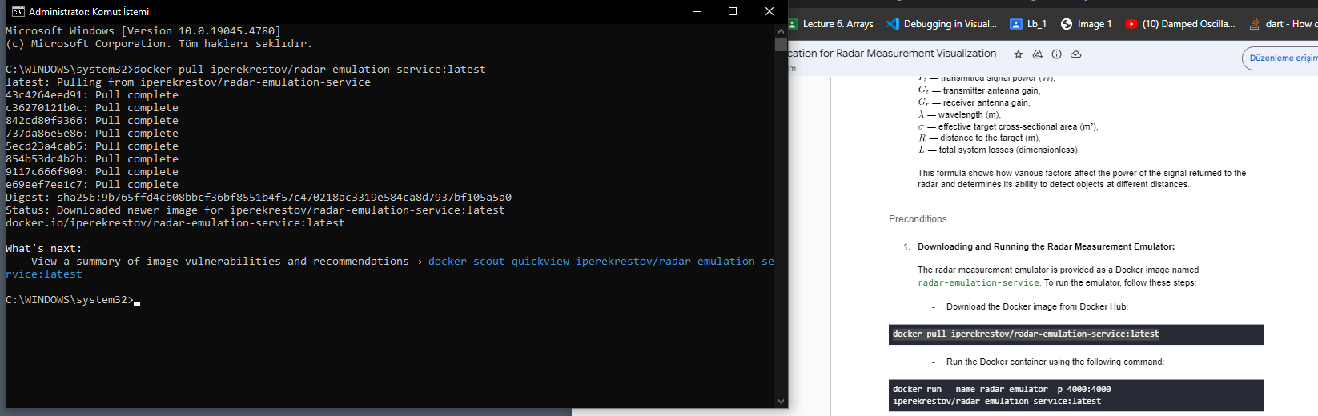
docker run --name radar-emulator -p 4000:4000 iperekrestov/radar-emulation-service:latest

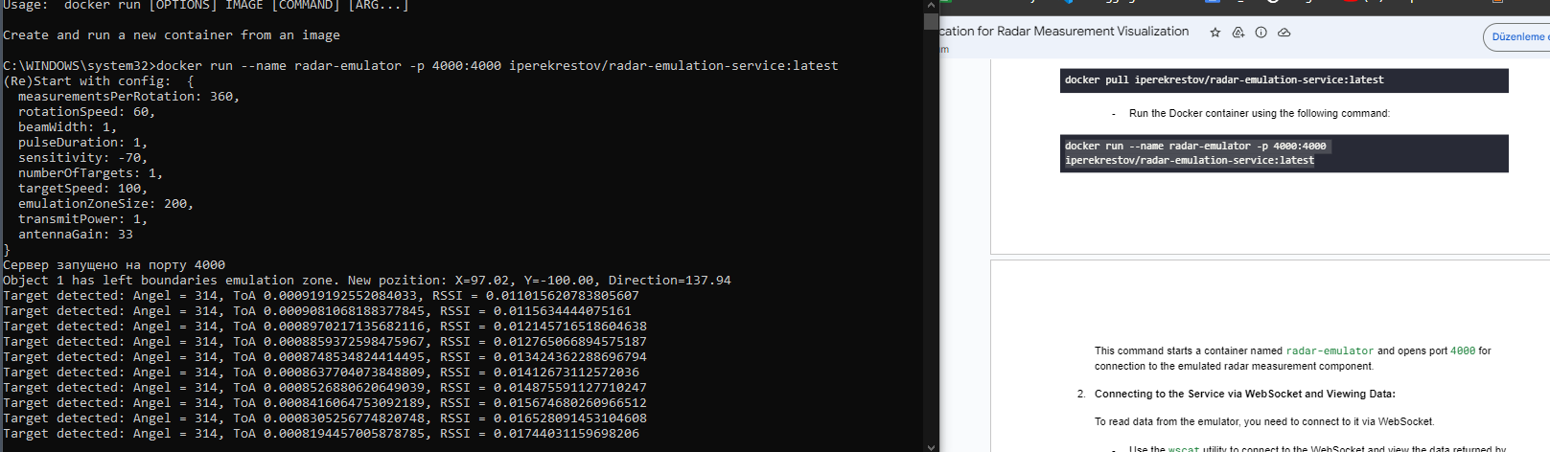
npm install -g wscat
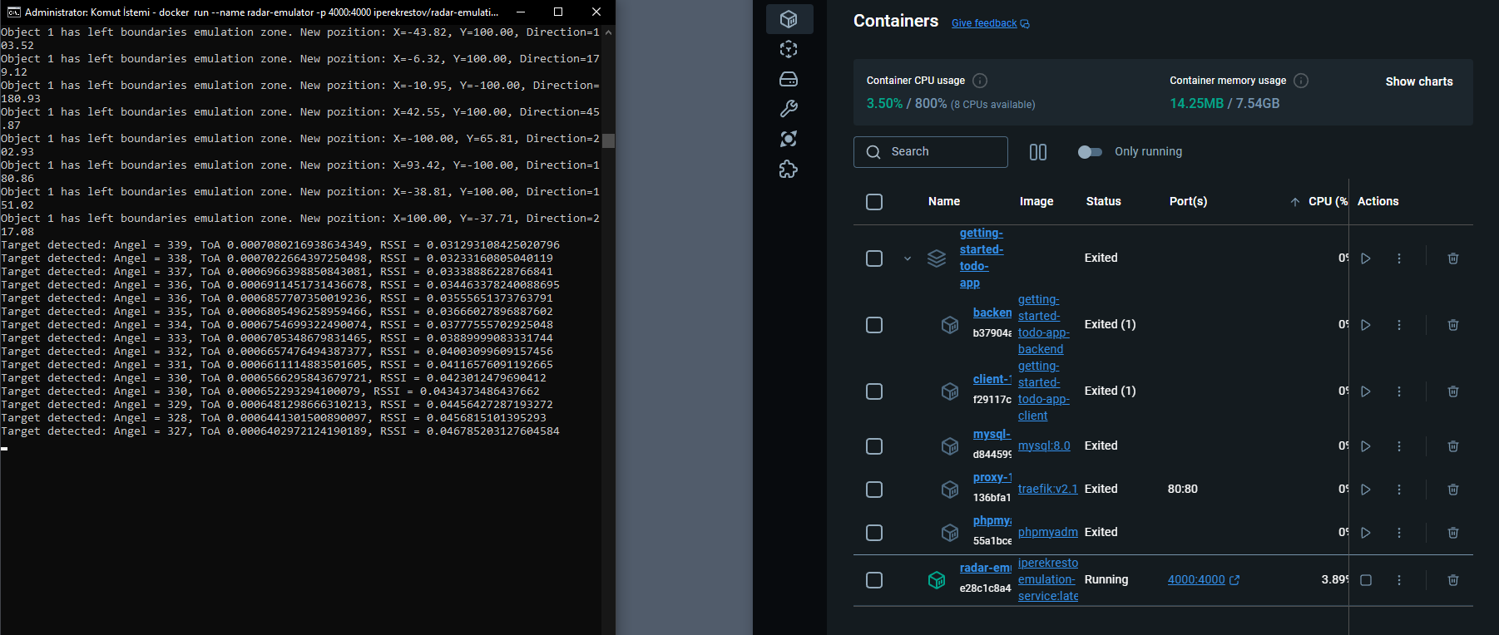

wscat -c ws://localhost:4000

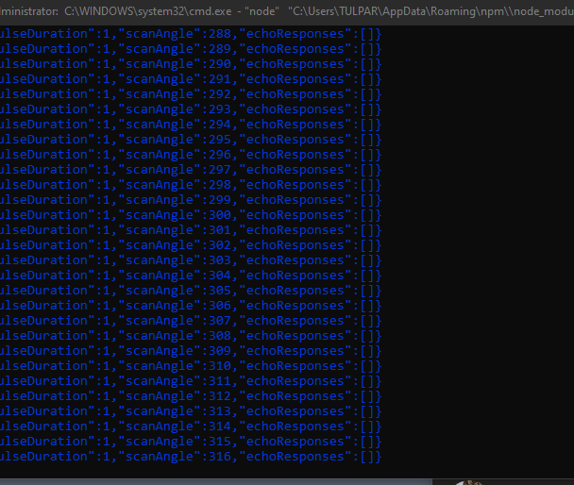

curl -X PUT http://localhost:4000/config -H "Content-Type: application/json" -d '{
"measurementsPerRotation": 360,
"rotationSpeed": 10,
"targetSpeed": 500
}'

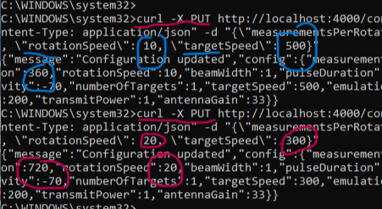
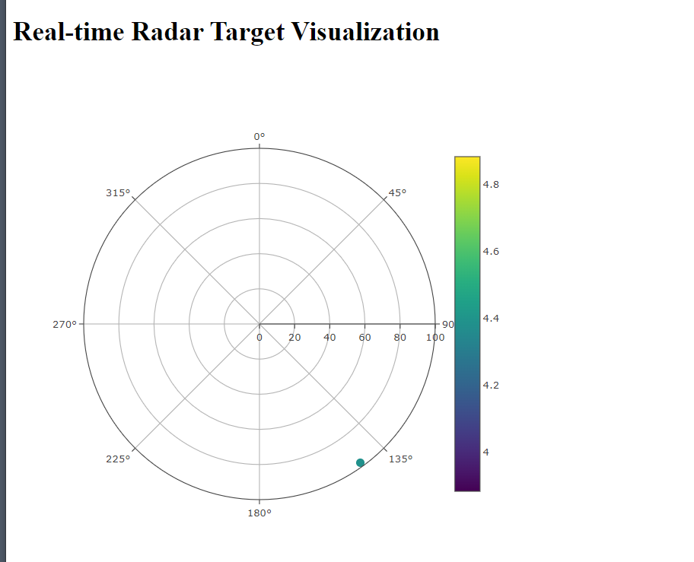
curl -X PUT http://localhost:4000/config -H "Content-Type: application/json" -d '{
"measurementsPerRotation": 720,
"rotationSpeed": 20,
"targetSpeed": 300
}'

